# Instructions and Due Date

This is an individual assignment. Please submit answers on a separate Word or PDF document before our next class**.**

You use the book T-SQL Fundamentals, SQL Server Management Studio, and SQL Server Express or Dbeaver (if using a MAC) to complete this homework.

## Set up and submission instructions:

This uses the same database from homework one created from the TSQLV4.sql file. Save the queries in a text or SQL file using your name and _hw3 (e.g. <studentname>_h3.sql) or similar convention and upload to blackboard. Please be sure that the SQL queries executes without errors as I will perform a test run of each query.

# Query Exercises (12.5 points each exercise with 5 bonus points for # 9).

1. Return orders placed in June 2015. Tables involved: TSQLV4 database, Sales.Orders table. The output should look similar to:  
    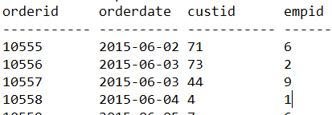
2. Return orders with total value(qty*unitprice) greater than 10000 and sorted by total value. Tables involved: Sales.OrderDetails. The output should look similar to: 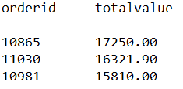
3. Return the three ship countries with the highest average freight for orders placed in 2015 Tables involved: Sales.Orders table. The output should look similar to: 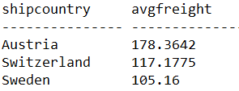
4. Write a query that returns employees who did not place orders on or after May 1st, 2016. Tables involved: TSQLV4 database, Employees and Orders tables. The output should look similar to: 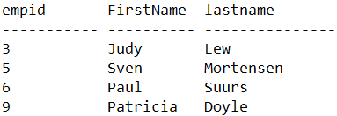
5. Write a query statement that generates 5 copies out of each employee row- Tables involved: TSQLV4 database, Employees and Nums tables. The output should look similar to: 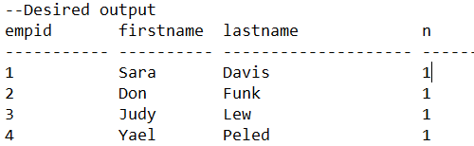
6. Explain the difference between “IN” and “EXISTS.”
7. Use a SELECT INTO statement to create and populate a new table Sales.Order14To16 with orders from the Sales.Orders that were placed in the years 2014 through 2016.
8. Alter the table in step 7 to add an integer column called ‘FiscalYear.’ Use an UPDATE statement to set the value of FiscalYear column to equal the year the order was placed except that if the month is October, November, or December you will add one year to the year. Include the SQL Queries for both (one to alter the table and the second to update the value).
9. Optional Extra Credit Question: Return all customers, and for each return a Yes/No value depending on whether the customer placed an order on Feb 12, 2016. Tables involved: TSQLV4 database, Customers and Orders tables. The output should look similar to: 